Naked-Eye Astronomy Lab

Measuring the Distance of an Outer Planet Using Parallax

(Math needed: trigonometry and algebra)

The primary method of measuring distances of the nearer astronomical objects is by use of the phenomenon of parallax. As the Earth moves around the Sun in its orbit, the relative positions of the nearer objects appear to change relative to those of the more distant objects. To see this effect firsthand, hold your thumb up in front of your eyes, close your right eye and take note of the apparent position of your thumb in projection against the distant objects in the room, as seen by your left eye. Then close your left eye and open your right eye while holding your thumb still and note that the thumb appears to have moved relative to the background objects. This phenomenon--the apparent movement of nearer objects due to the motion of the observer--is known as parallax. Through simple geometry one can determine the distance of an object from a measurement of the angle that an object appears to move, as shown in Figure 1 below. (In fact, this is what your brain does with your two eyes to give you depth perception and why you have no depth perception with just one eye.)
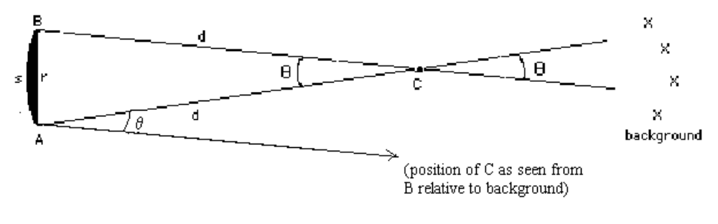Figure 1: The observer moves a distance r from point A to point B and sees that the nearby object, at point C, appears to move relative to the background objects by an angle θ. Since the background objects are essentially infinitely far away, in comparison to the distance of the nearby object at C, the angle between the positions of the object at C relative to the background objects, as seen by the observer at A and B, is the same as the angle between these two positions as seen from point C. Additionally, if the distance the observer moves is small relative to the distance of the object, i.e. r << d, then the isoceles triangle A-B-C is approximately the same as a thin wedge of a circle centered at C. The only difference between the wedge and the triangle is that the straight line distance from A to B, i.e. ‘r’, is not exactly the same as the arc length from A to B, i.e. ‘s’.

By the rule of opposite angles in two intersecting lines, the angle θ is equal to the angle of the wedge of the circle. And, by the small angle approximation θ(radians) ~ r/d. Rearranging, then, to get an equation for distance, we have d = r/Θ(radians). (1)
The nearest objects in space are the Moon, Sun, and planets; the stars are much much further away and work well as background objects. Since the Earth moves through space in its orbit around the Sun, and we observe the sky from the Earth, we can measure the distance to an outer planet, such as Jupiter or Saturn, by measuring its parallax angle relative to the distant stars when the Earth moves a known distance. This is the goal of this lab. You will take photographs of the sky centered on an outer planet on different days and measure the angle that the outer planet appears to move relative to the background stars. We'll discuss below how to actually measure this angle. This will be the angle θ in equation (1) above. And, since you know the size and period of Earth's orbit (the Earth’s distance from the Sun is 1.5 x 10⁸ km or 9.3 x 10⁷ miles), you can calculate the distance that it moves in any given number of days. This is the distance r. As your first task for this project, be sure that you understand how to calculate the distance that Earth moves for any given number of days. Try using 10 days, for example.
Note that the motion of the Earth in Figure 1 is perpendicular to the direction of the nearby object at C. This is not, though, the case in general. If the observer moves in some random direction then the isosceles triangle in Figure 1 looks more like the triangle below,
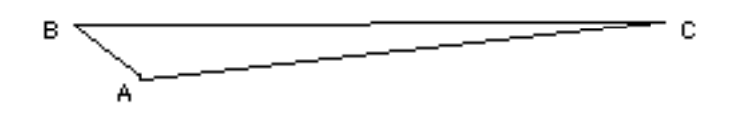
and then the distance from A to B is different and equation (1) is wrong. So, to do this project, you need to be sure that the motion of the Earth is perpendicular to the direction of the outer planet. When can we be sure of this? Consider what determines the direction that the Earth moves. The Earth moves because it is in orbit about the Sun. Since its orbit is very close to a circle, its motion is approximately perpendicular to the direction of the Sun. Therefore, its motion is perpendicular to the direction of the outer planet only when the outer planet is in the opposite direction from the Sun, as shown below. This configuration is known as opposition of that planet. Your instructor will tell you when Jupiter or Saturn is at opposition.
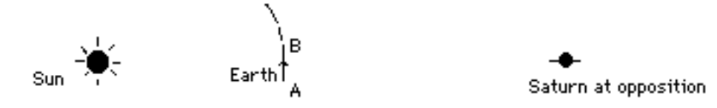
There is one other complication that one should account for. Since correcting for this complication properly involves a lot of gory geometry and trigonometry you will not be required to do it You should, though, understand the nature of the complication, explain why your result gives the wrong answer, and estimate the magnitude and direction of this error. For those students who either are comfortable with upper level High School math or who want to try to follow through with the project all the way to the correct answer, instruction on how to make this correction is explained in an appendix. This second complication is that the outer planet is not absolutely fixed at point C. In the time between observations, the planet has moved a bit also. Fortunately, outer planets moves through space much more slowly than Earth, so your results will only be a bit off. Consider the figure below, which demonstrates the correct geometry for an observation of Saturn and including the motion of Saturn. It is your task, now, to figure out the direction of the error and estimate the magnitude of the error in your final answer due to the motion of the outer planet.

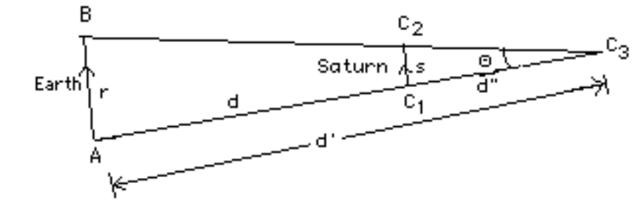
Figure 2

How to Measure the Angle of Parallax:
Use a single lens reflex camera, whose exposure time is adjustable (i.e., not a fully automatic camera), with a shutter release cable, film of ASA 200 or 400, and a tripod, to take a picture of the region of the sky centered on Saturn. Do this on two different nights separated by about at least a week.
You'll first need to locate the planet in the sky. (You can do this with the aid of a "Star and Planet Locator"). After you find the planet, check with your instructor to be sure that you found the right object (you don't want to waste your time taking a picture of a star that will show no parallax). Then set up your tripod and camera to aim at the sky centered on the planet. It is best to do this in a dark area with a clear view of the sky.
Set the camera to focus on infinity and on the largest aperture setting (i.e., smallest f-number) to increase the "light-gathering power" of your camera. Take a number of pictures with a range of exposure times, from about 1/4 second to about 15 seconds. For the longer exposures, you'll need to set the exposure to manual (this is often indicated by 'B') and time it with your watch. Since the response of the film is porportional to powers of 2, you'll only need exposure times of 1/4, 1/2, 1, 2, 4, 8, and 15 seconds.
One very common mistake is improper loading of the film, so that the film doesn't wind properly. Watch your film knobs to be sure that they rotate when you advance the film.
Although the region of the sky containing the planet may appear empty to you, the picture that your camera takes will contain a number of stars around the planet that are too faint for your eye to see. There are two reasons that the camera is able to pick these stars out better than your eye: 1) by using a large aperture, your camera gathers much more light than your eye does, and 2) your eye only collects the light for about 1/120 th of a second, whereas with the longer exposure times you use with the camera the light will be added for a longer time, increasing the apparent brightness of all objects.
Keep a careful log of your data. Record the date, time, and observing conditions (crystal clear, hazy, partly cloudy,...). Carefully record the exposure time of each picture so that when you get your film back you can determine which exposure times worked best (and be sure to state this in your report).
Get your roll of film developed as soon as possible so that you’ll see the results from the first night before going out the second week--you can then use fewer exposures since you’ll know better what works well. You'll only need the negatives, so if the other exposures on the roll are unimportant to you, you can save money by only asking for the negatives (no prints). Make it absolutely clear to the developer that a) your pictures will only be little dots--so don't throw them away, and b) that you want the negatives on the roll--don't cut the roll.
When you get the negatives back, you can examine them with a light table and pocket magnifier (a.k.a. a “loupe”) in lab the next week. What you want to see is that the planet appears as a dark spot that is not streaked (if it is, then it was exposed too long and the movement of the sky caused the planet’s position to change during the exposure. This would make your estimate of its position difficult) and that there are a number of other dark spots due to surrounding stars. Record in your log your estimate of the quality of each image, and refer to these notes in the next round of pictures.
The second week, we’ll go out again so that you can take some more exposures. When you have (at least) two sets of negatives, you are ready to measure the parallax angle. In lab the next week, again use the light table and pocket magnifier. Take the best exposures from each night, and examine them and see if you can find the same pattern of stars in them. Don't worry if the planet has appeared to move relative to the stars--that's what you want, that's parallax. When you have identified the stars, overlay the best images from each week, using the pocket magnifier, so that the stars line up. This will most likely involve a shift and a rotation of one negative relative to the other, because it is unlikely that you will have the camera set up exactly the same relative to these faint stars on both nights. You should now see that the planet has indeed moved. Using the millimeter scale shown on the pocket magnifier, measure the number of millimeters that the planet has appeared to move on the negative.
Now, how does this measurement in millimeters relate to the parallax angle? Consider the lens of the camera, which is responsible for creating the image. Since the lens is symmetrical, light going through it in one direction must follow the same path as light going through the other way, as depicted in the Figure 3. Therefore, the angular distance that the image of the planet moved on the negative, as seen from the center of the lens must be the same as the angular distance that the object moved in the sky.
The angular distance on the negative is, by the small angle approximation,
Θ(radians) = l/f, (3)
where l is the linear distance on the negative and f is the focal length of the lens. (Note, the distance of the 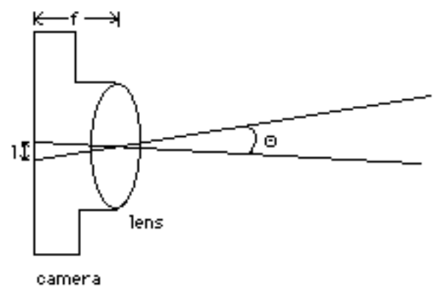
Figure 3
negative from the lens is f only if the camera is focused at infinity. For pictures of closer images, the focus occurs at a different distance of the lens. As astronomers, though, we are lucky in that focusing is an easy task for us because all objects that we are interested in are essentially at infinity, from a photographer's perspective.) So, any distance l on the negative corresponds to an angle θ in the sky as given by equation (3).
Use equation (1) or equation (2) (in the Appendix) to calculate the distance of Saturn.

In Sum, then, the procedure is:
1. Using a star and planet locater determine at what times the outer planet will be up after dark and where in the sky it will be.
2. Take your tripod and camera to a dark area with a clear view of the sky and set the tripod and camera up to aim at the sky centered on the outer planet.
3. Set the camera to focus on infinity and on the largest aperture setting (smallest f-number) and take exposures for a range of exposure times, from the smallest possible value up to 15 minutes. Record the date, time, and observing conditions (crystal clear, hazy, partly cloudy,...). Carefully record the exposure time of each picture so that you can state in your report which exposure times worked best.
4. Repeat steps 1 through 3 the following week.

Appendix: Correcting for the outer planet’s Motion (only for those with a strong stomach for math)
For those that are willing to deal with the math, let's discuss how to correct for the motion of the outer planet. We need just one other piece of information--Kepler's harmonic law for the orbits of the planets. This law states that the period of a planet’s orbit is related to the average distance of that planet from the Sun by:
P² = a³,
where P is the period of the planet’s orbit in Earth years and a is the distance from the Sun in Astronomical Units (which is the distance of the Earth from the Sun). It is very important that you use the proper units. This equation is not true if you used miles and hours, for example.
Let's first discuss how to figure how far the moved moved. In general, you can determine the distance the planet travelled in a given period of time if you know the velocity of the planet. As you did with the Earth, above, then you can calculate that if you know the planet’s orbital radius and period. You can get the period from the radius using Kepler's 3rd law. So, then, what you need is the planet’s orbital radius, or its distance from the Sun. Well that is very closely related to what you are trying to find. If d is the distance of the planet from the Earth when it is at opposition, then its distance from the Sun is just d+1A.U. (where 1 A. U. is the distance of the Earth from the Sun). Therefore, you can set up an equation for the planet’s velocity that involves known quantities and one unknown--d. And, hence, you can set up an equation that involves the variable d for the distance traveled by planet for any given period of time.
Now consider Figure 2. Note, first, that the inferred parallax angle, θ, yields the distance d', not d. That is, θ=r/d'. Secondly, consider the direction that the planet moves. Because the planet orbits the Sun in approximately a circle and the Earth is very close to the Sun, compared to the distance of Jupiter or Saturn, the planet's motion is approximately perpendicular to the direction of the Earth. Therefore, the line representing the distance that the outer planet travels produces another isosceles triangle--C1-C2-C3, and since this triangle also has the angle θ at the apex, it is identical in shape to A-B-C3, only smaller. So, if s is the distance that the outer planet travels and d” is the distance from the planet to point C3, then θ~s/d”, or d”~s/Θ. And, since d+d”=d’, then d=d’-d”. Therefore, to get d, you need to first calculate d’ (=r/θ), then d” (=s/θ), and subtract. θ is the parallax angle, which you will measure, r is the distance that Earth moves between the two observation dates, and s is the distance that the planet moves between the two observation dates. However, you cannot solve for s by itself because you can only figure it out in terms of d, which is what you don't know and are trying to figure out. So, you'll need to put all these equations together (using algebraic substitutions—ask for help if you need it) to set up an equation that involves only d and known or measurable parameters. You should be able to get an equation that involves only d, Δt, the time between exposures, and θ, the parallax angle. You can then manipulate this equation to solve for d in terms of Δt and θ. Try figuring this all out on your own, but feel free to ask for help and to check your answer. Write your final equation for d in the space below. This is your equation (2).

(2)

